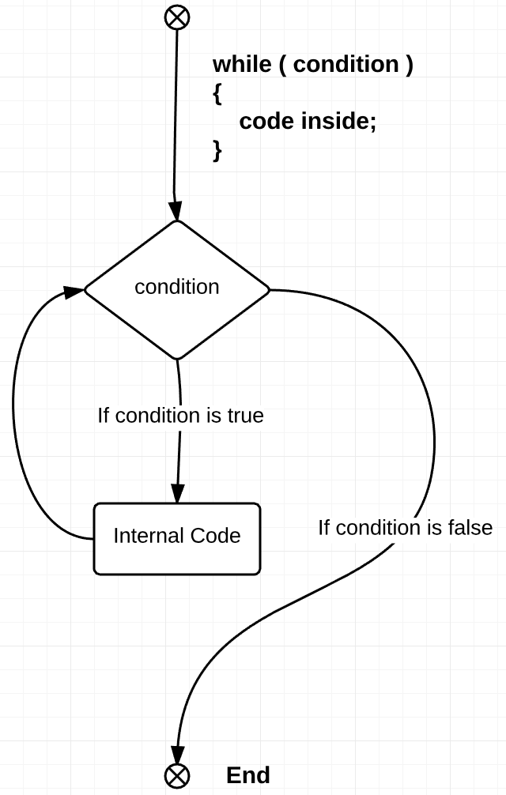Level 1 is supposed to first show the physics of the game, and then to teach first programming terminology – “while” loop. In computing, “while” loops are very commonly used. Despite the fact that this is one of the most basic functions, it is viable for almost any application.

The way it works is that it will repeat a set of internal functions (within the loop) up until the point when the condition is false. At this stage, the loop ends and the next function is executed. *See Figure 1 for further reference.*

An easy example will be to imagine a user creating documents. Suppose, there is a template of that document. This template is specified in a code. However, what if you need 2-3 or even more templates? You will either re-run the program that number of times, or you could simply ask the user “What number of templates do you need?”. You can then place that number inside the loop. It should look such as the computer will read “run the same process 3 times”.

This is exactly what we are trying to show in the program. The character (mars explorer) will run up until it reaches the final position. Before that, it will move as many steps as we need (3, in our case). That is another benefit of using “while” loops. You may not even know the actual number of iterations you need, and you still do not have to count them down. The “while” loop will do exactly as many as you need.

Figure 1: "while" loop process

However, there is one nuance. There might be a case of ‘infinite loop’. That is when the loop will run forever, because its condition was specified badly. In such situation, the program will not run forever – it will simply crash or make your computer reload. For this reason, be careful when choosing the right condition.